Timing record and motion detect record
Enter into main maunal in TV screen
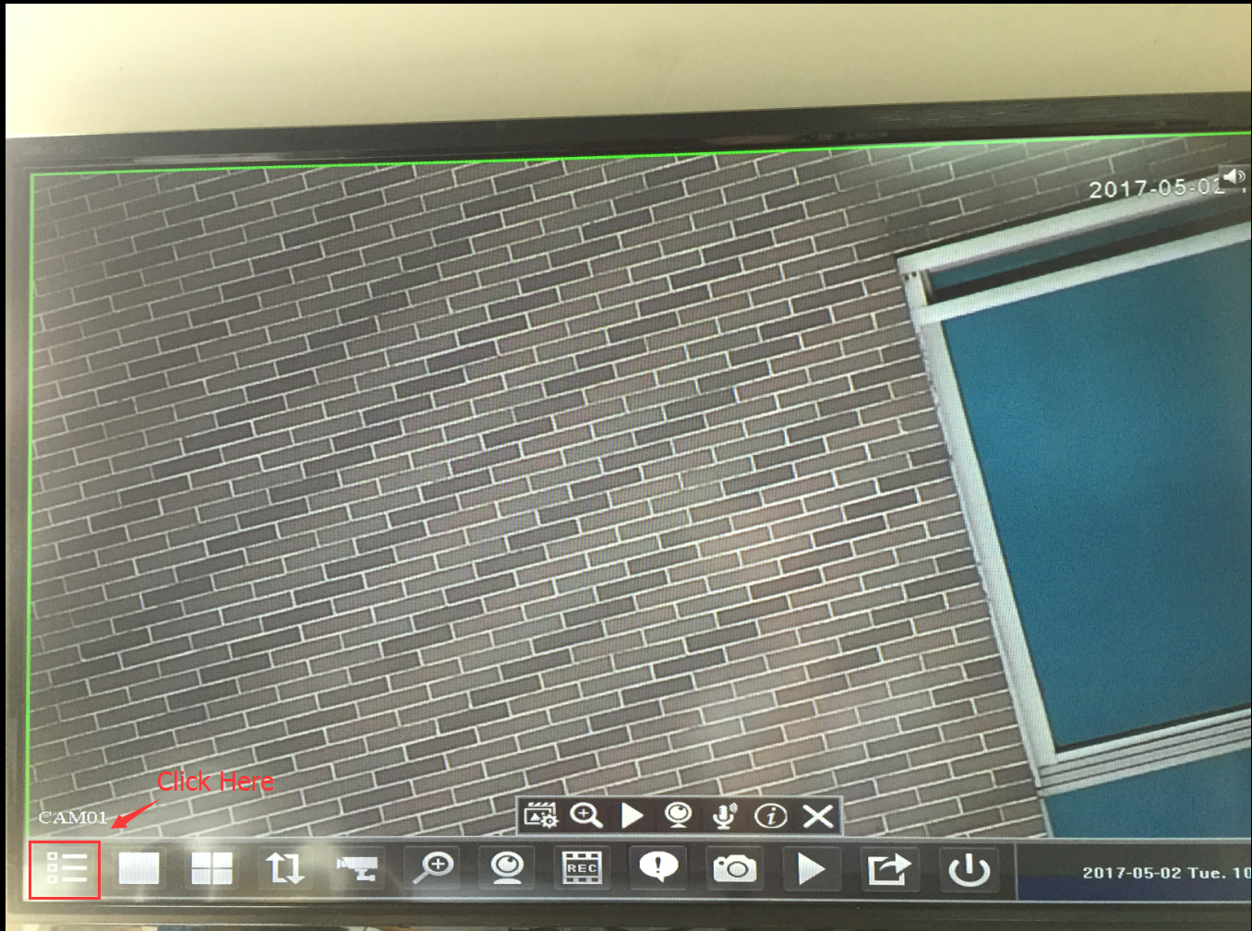
- Choose “record ” 。
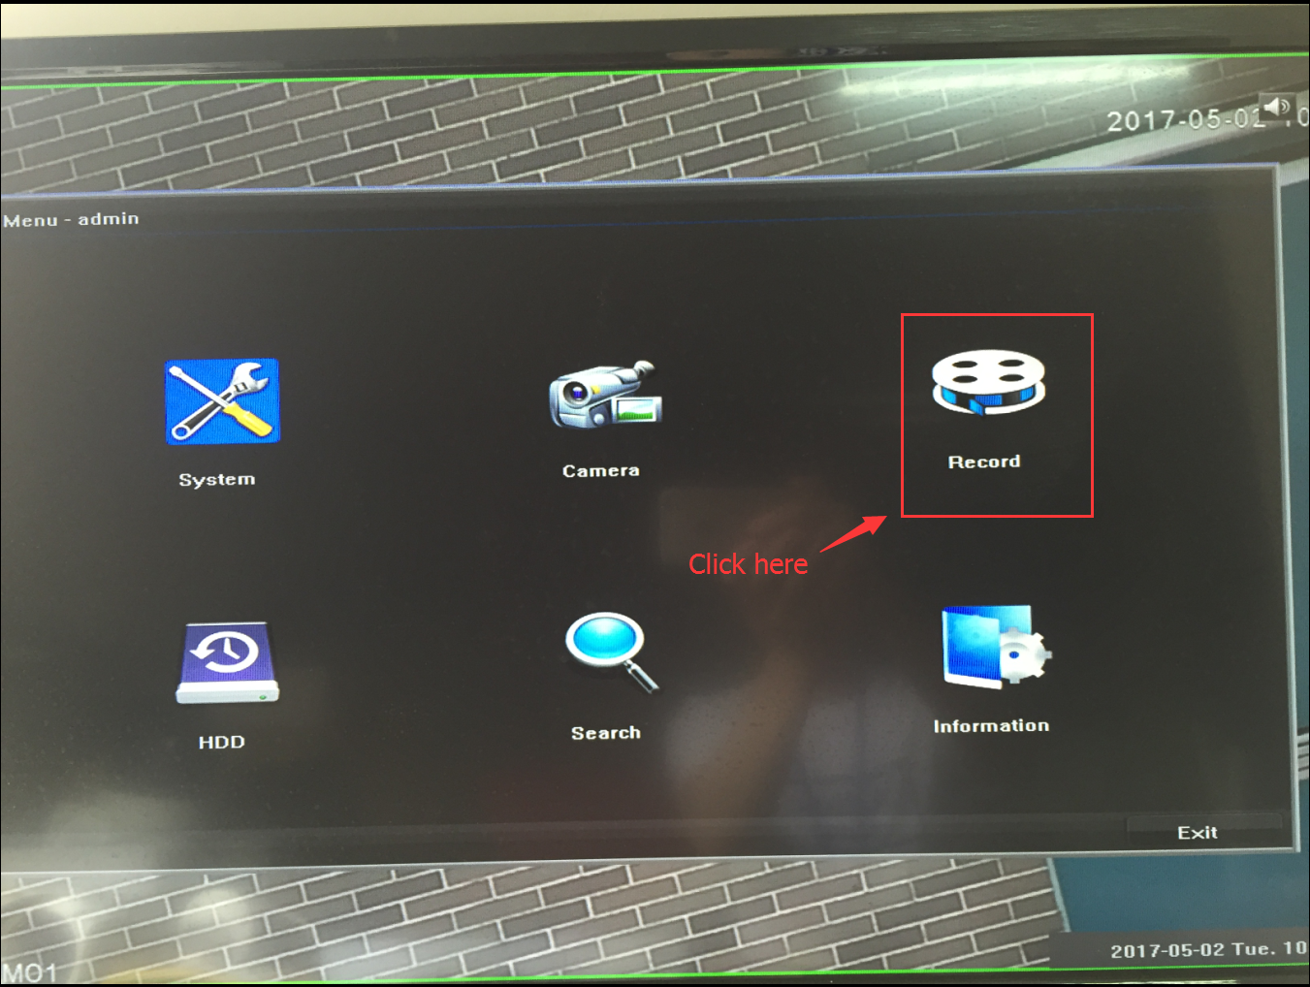
- First, select “ schedule” , in timing record setting，click “common”，and click left key on mouse to choose timing area （blue means chose）

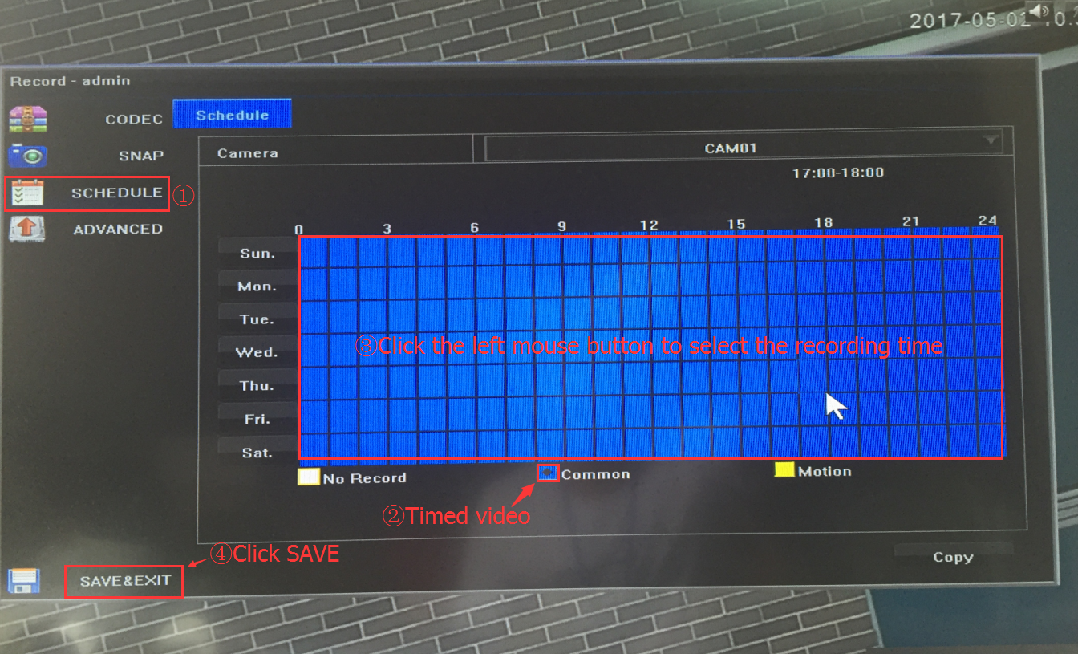

4.Click Copy to choose the channel you want to apply。
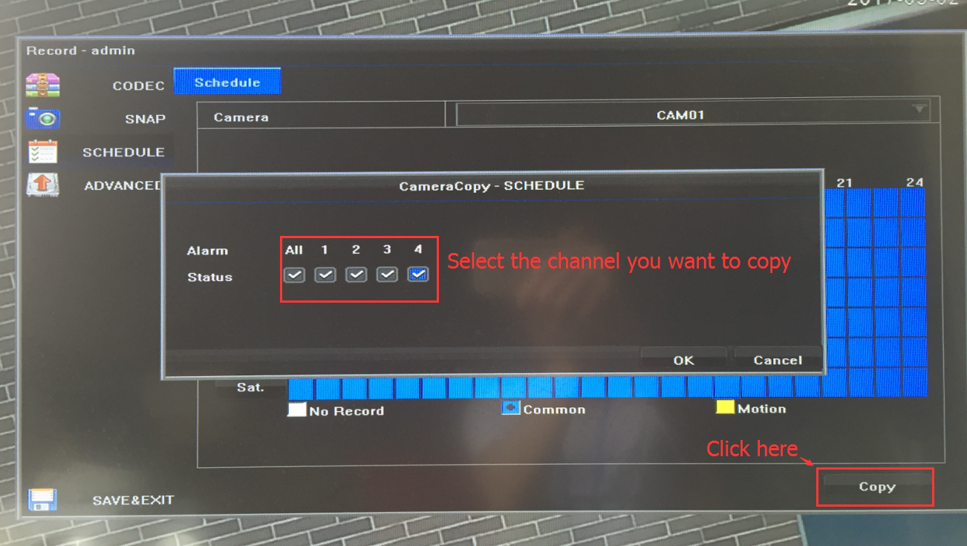

5.Click ok to save and exit
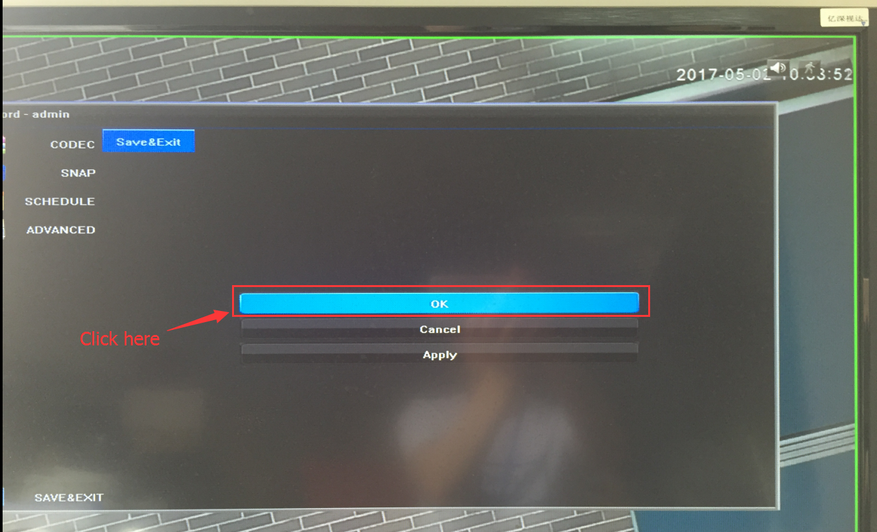

6.Motion detection record ( yellow is for motion )
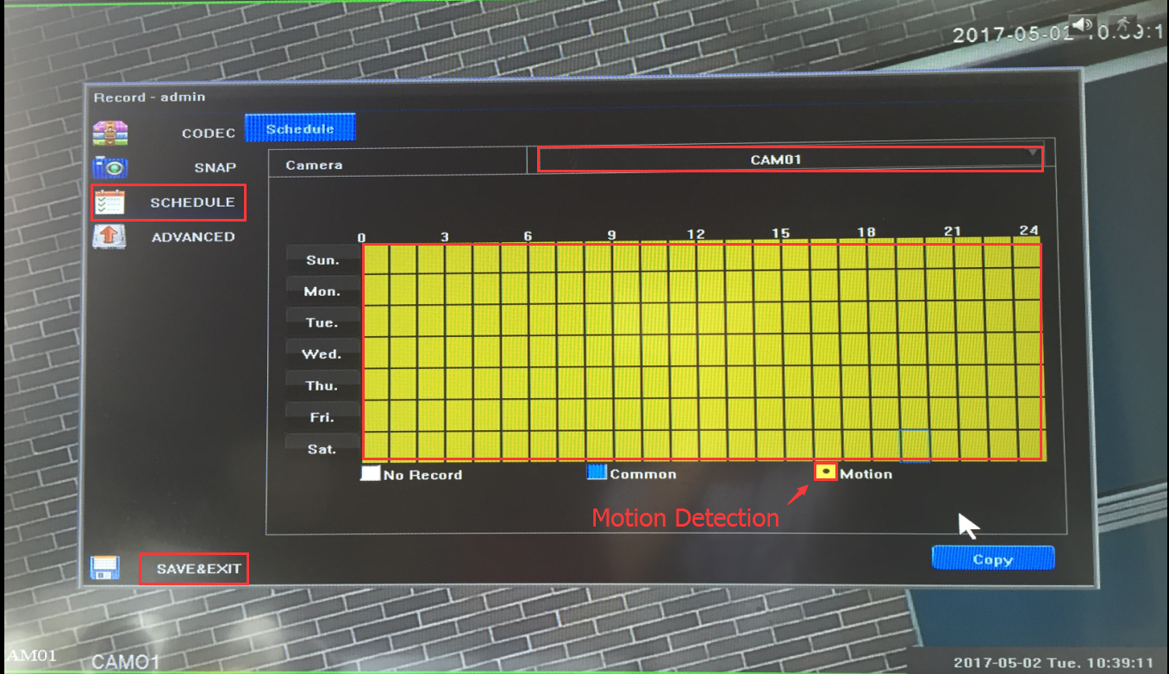

7. AS same as step 4 。
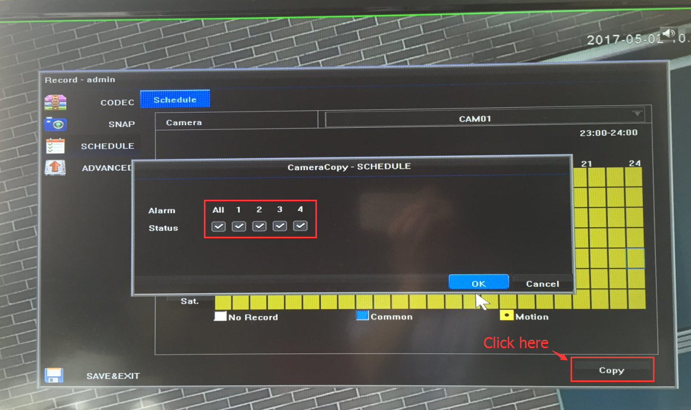

8．About playback
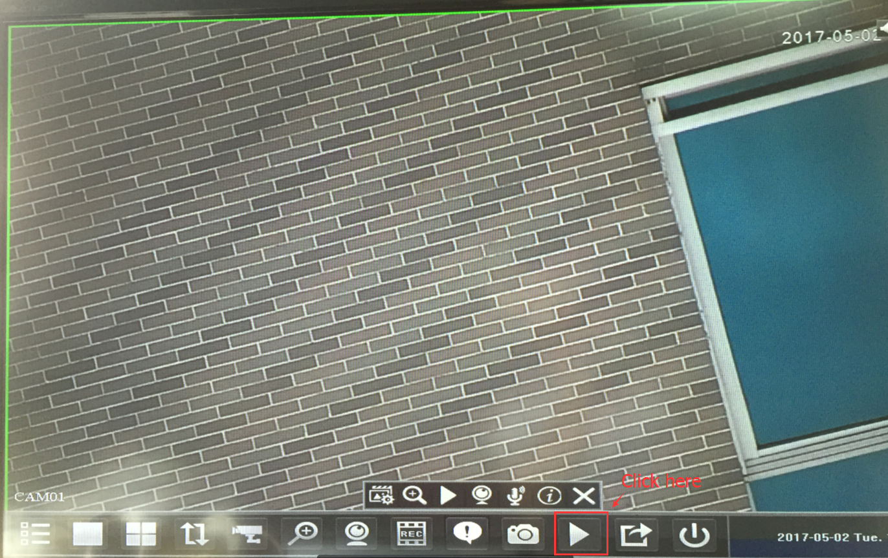

How to save video
1 choose “ Device”, first select NVR, second click “ config”
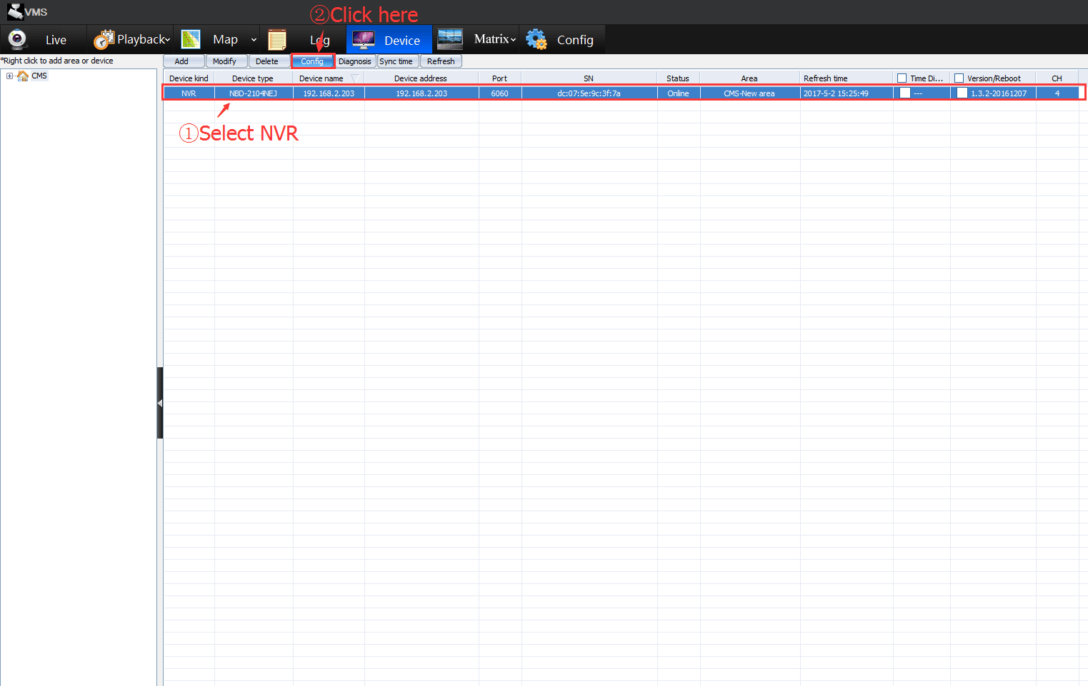
- Choose schedule, click the type you want to record , which is the same step as done on TV display
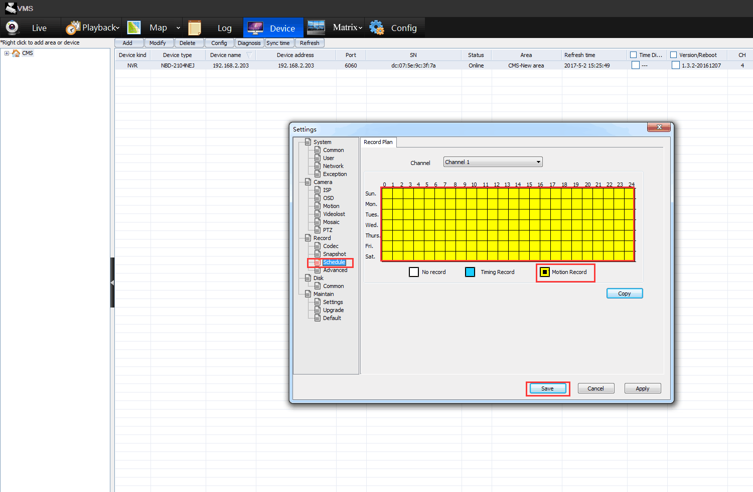
When you have done the setting on PC or display, it will synchronize with display or PC

