How to fix the pink problem of PTZ IP camera image
Cause: the day and night switch (IR-CUT) of the lens has malfunctioned, As a result, it cannot perform normal switching between day and night
Solution:
1. Users with poor hands-on ability can use this method:
Disconnect the power adapter and remove the camera from the wall. Then Put the camera in one hand. Use the other hand to pat the camera vigorously. It takes about 1 minute. And pat the camera body from different angles of the camera. (The purpose is to beat out foreign objects in the IR-CUT). After completion, install the camera again and the camera will work normally.
2. Suitable for households with strong hands-on ability.
Disconnect the power adapter and remove the camera from the wall.
Use a tool to remove the 4 screws as shown in the figure below. Then remove the back cover (please pay attention to the WIFI antenna on the back cover)
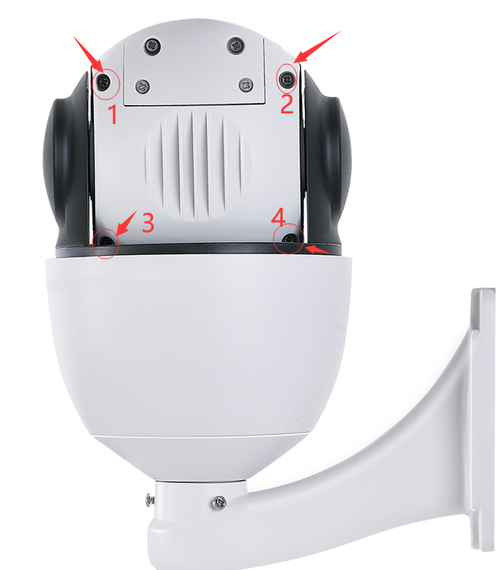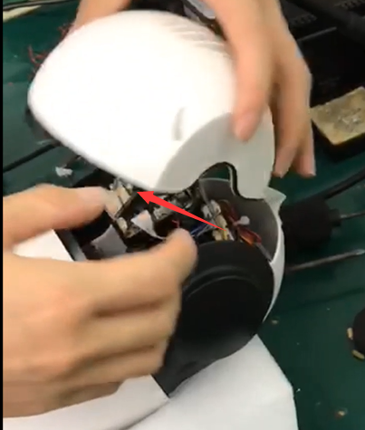
Then find the 2 screws on the main board of the camera and remove them. Remove all the cables on the motherboard, and then remove the motherboard (before unloading the cables, use the camera to take pictures of the positions of all cables for later recovery). You will see the 3 screws shown in the picture below, and continue to remove these 3 screws. And remove the black cover.
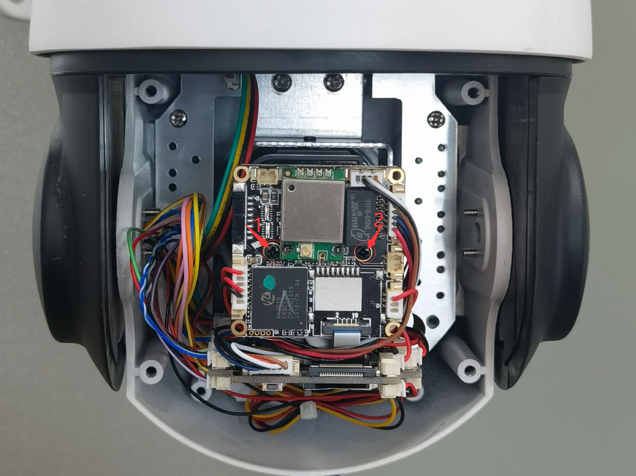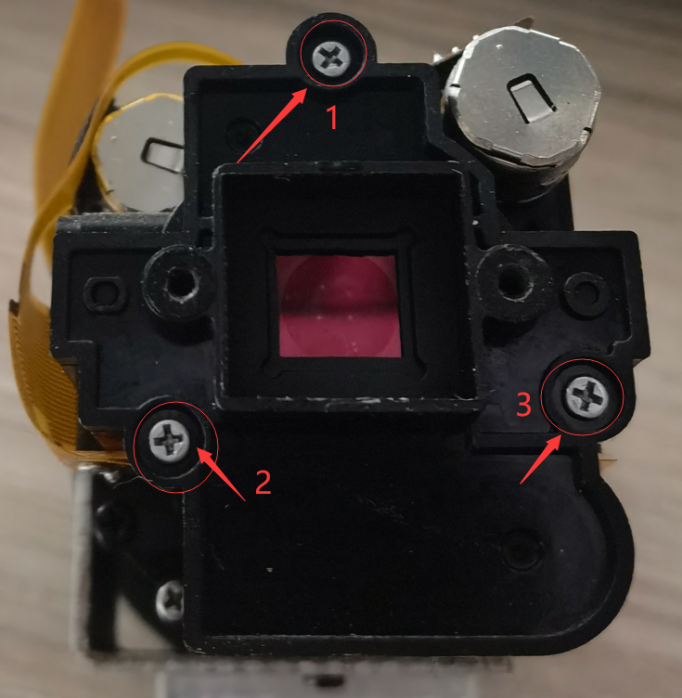

You will see a glass switch. It is the switcher (IR-CUT) responsible for the camera's day and night conversion. Please check carefully, the plastic pillar at position 1 here has broken. That is, it stuck the normal switching of IR-CUT. After taking it out, Your camera will continue to work perfectly. Then please close the cover, install all the screws and all the cables, and test the camera again.

