How to modify the working frequency of the wireless AP module
- Connect the serial port: Use the USB to UART tool, connect the TX, RX, and GND cables to the red box in the figure below.
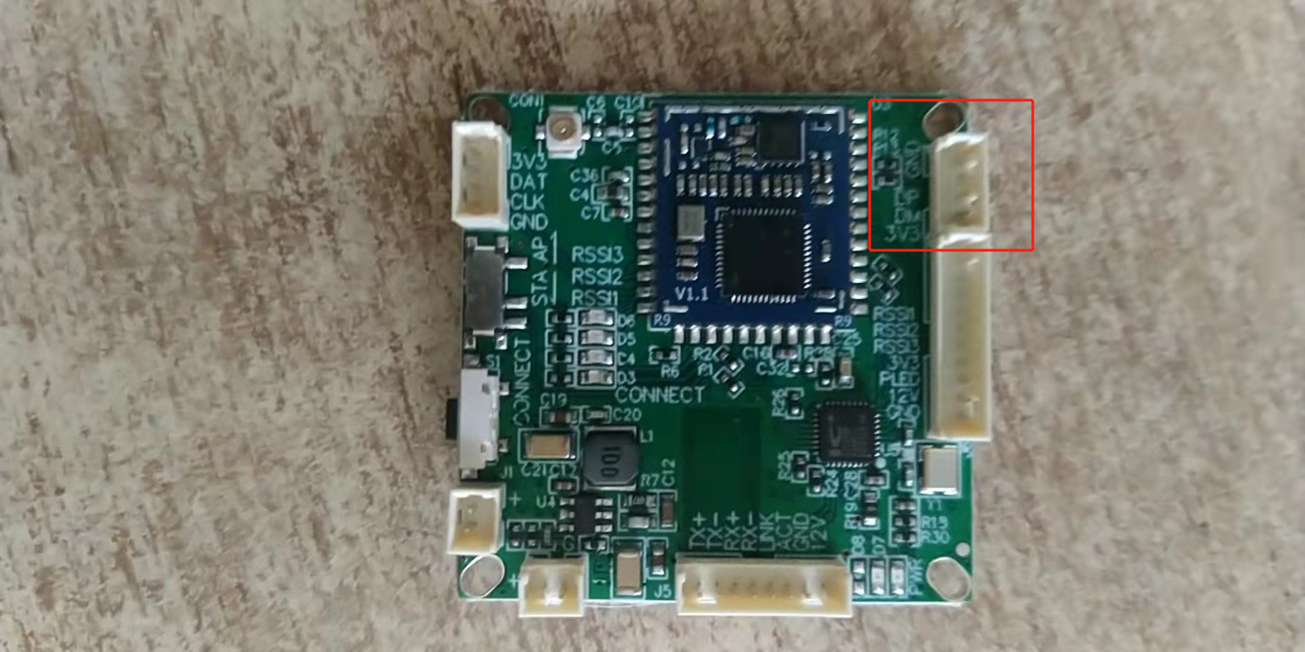

- Use the SecurECRT tool to open the serial port. Set the session options with a baud rate of 115200. Set to new line mode:
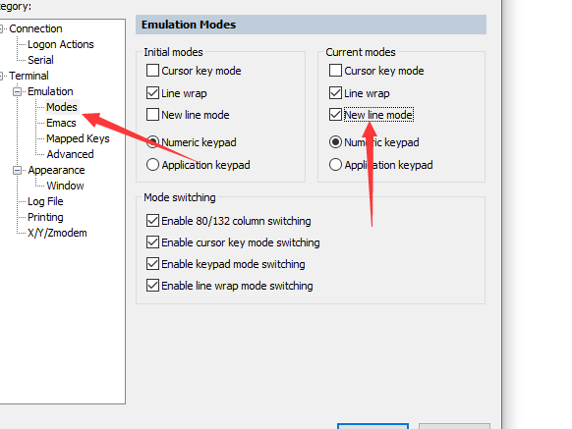

After printing, enter the at+command\r to see if there is a response, such as at+mode\r
3. View channel list:
AT+CHAN_ LIST\r
Return the result, such as:
+CHAN_ LIST: 9080,9160,9240
Ok
4. Configure channel list:
AT+CHAN_ LIST=Center frequency of Channel 1, Center frequency of Channel 2, Center frequency of Channel 3\ r
For example, if configured with only two channels:
AT+CHAN_ LIST=9160,9240\r
To configure as a channel:
AT+CHAN_ LIST=9240\r
5,Modify the scope of work:
AT+CHAN_ LIST=9080,9160,9240
If you want to modify the center frequency to 9080, the setting method is:
AT+CHAN_ LIST=9080\r

6. Modify bandwidth:
To modify the bandwidth to 8M, enter: at+bss_bw=8\r

