How to replace the POE module of PTZ IP CAMERA
Disassemble the main body of the camera and divide it into two parts. As shown in the following figure

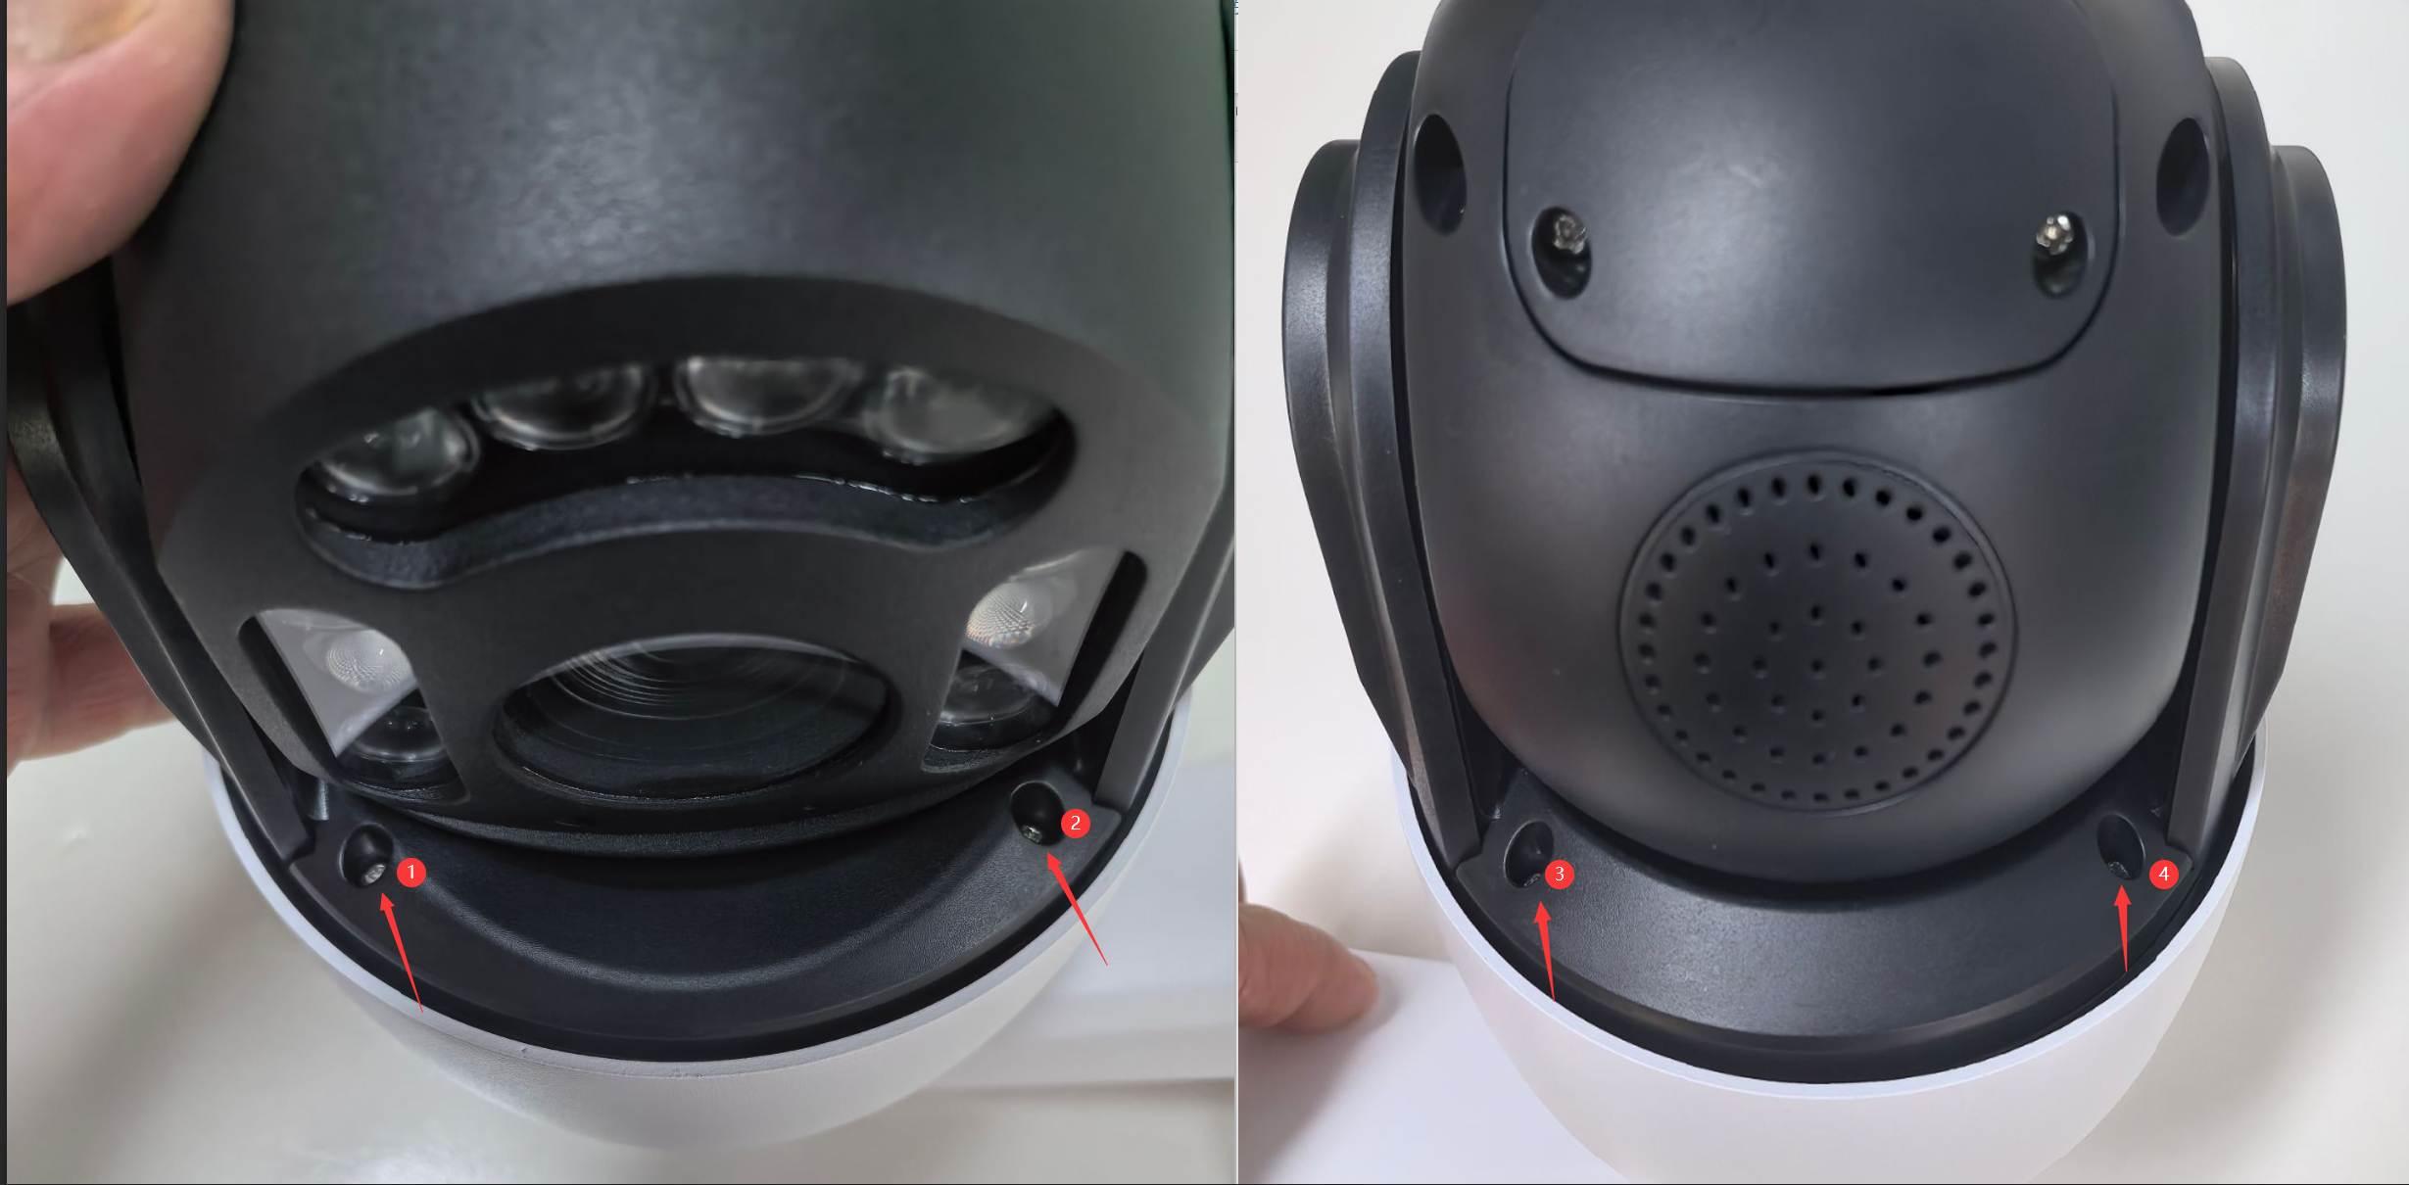
Separate the upper and lower parts. Please pay attention to the connecting wire in the middle and do not damage it. As shown in the following figure:

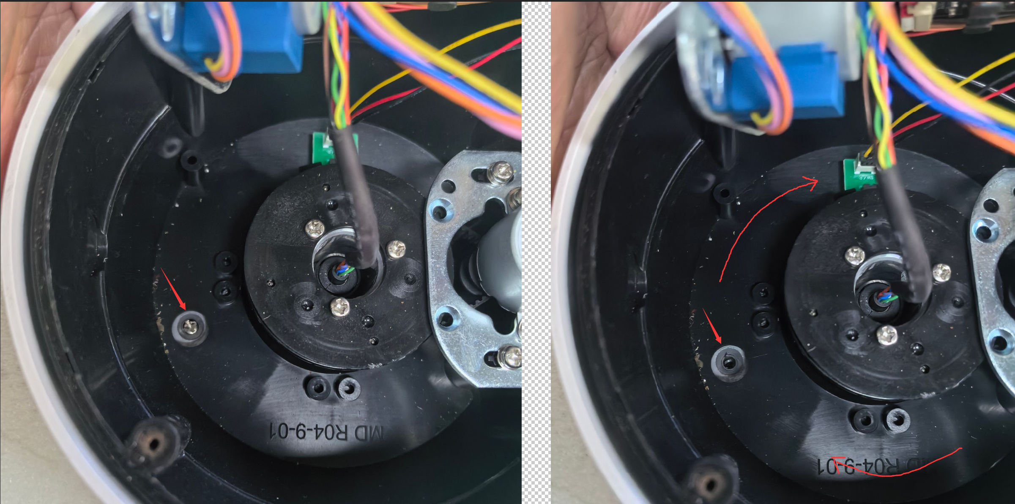

Distribute 4 screws on this disk, rotate the disk, and you can find these 4 screws separately and remove them. And take out this disk, as shown in the following figure:
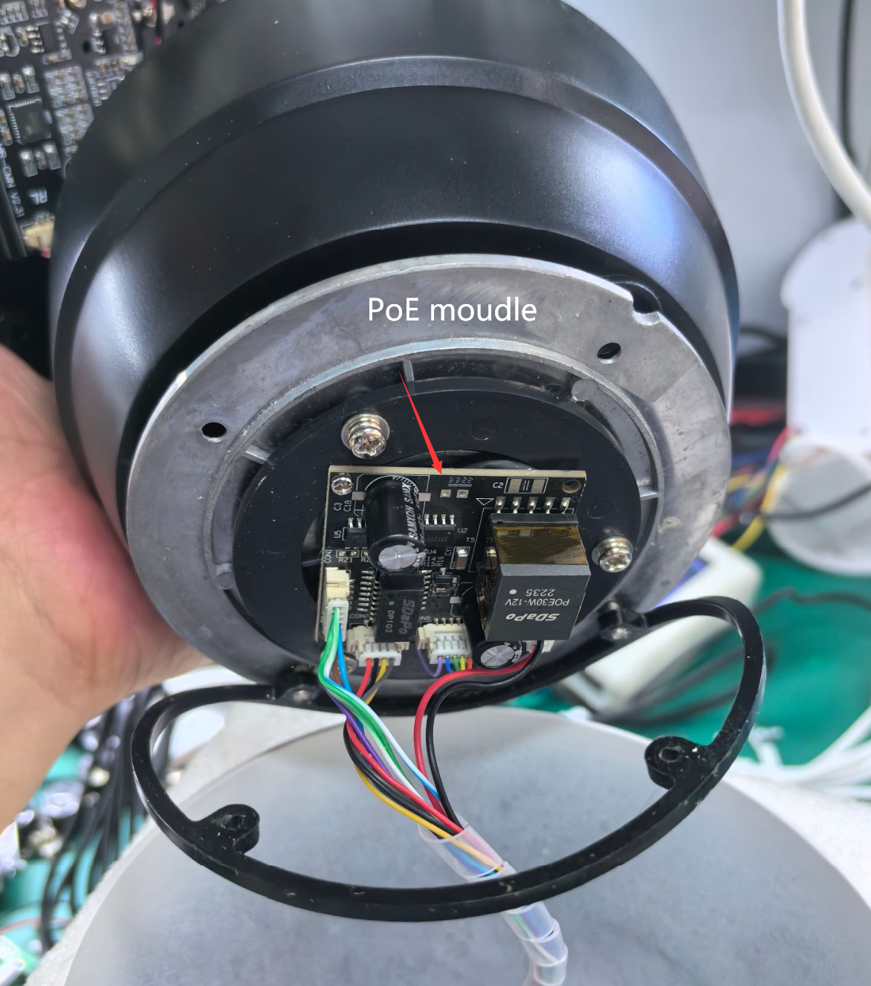

You can uninstall this POE module and replace it with a new one. Please pay attention to the waterproof rubber ring here. After replacing the POE module, it is necessary to install the waterproof ring on the bottom shell in advance, as shown in the figure:
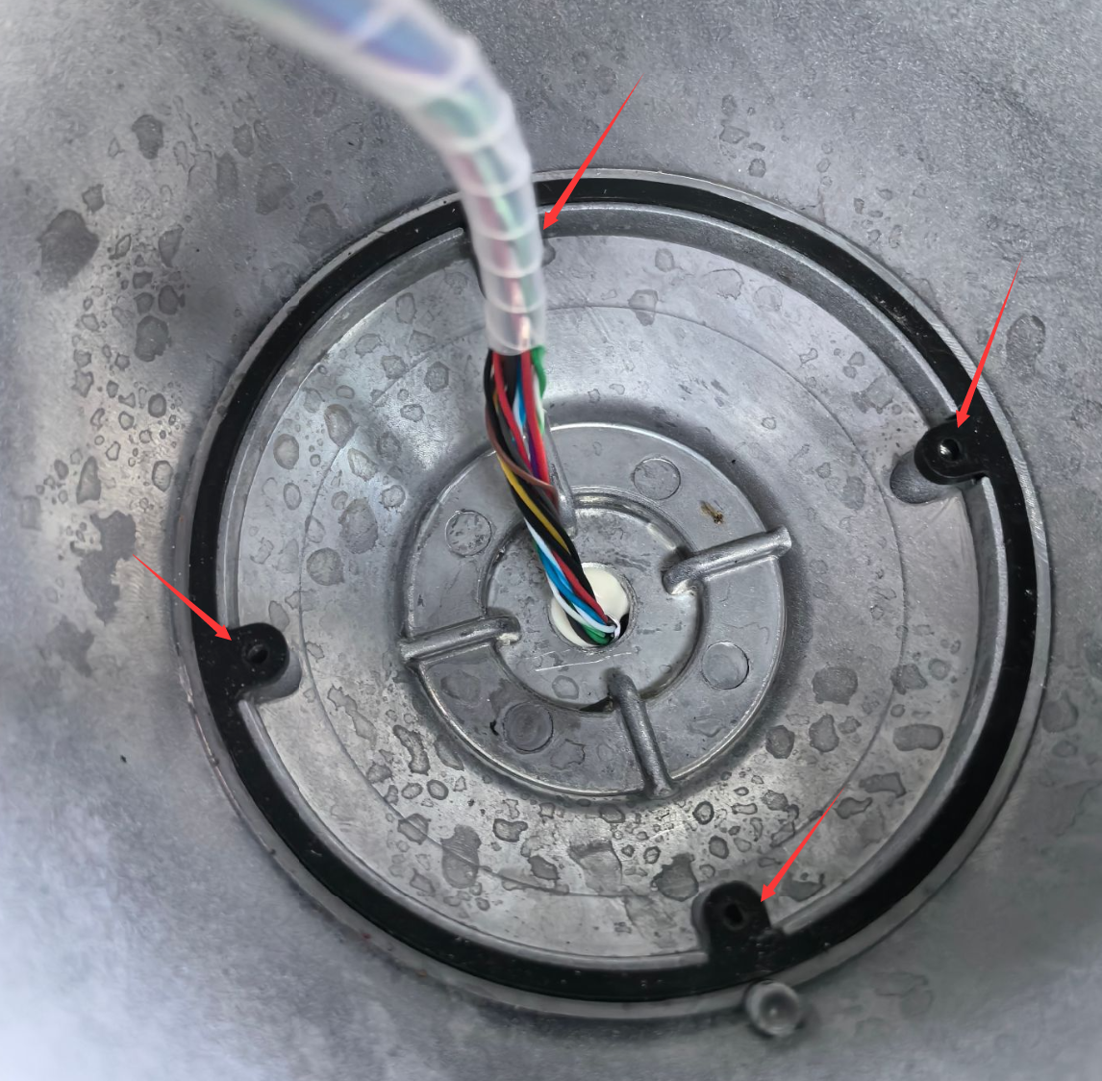

After everything is completed, the black disc can be installed on the bottom shell. It should be noted that there is a positioning mark on the bottom shell that needs to be aligned with the black disc. Otherwise, you will not be able to find the correct installation method. As shown in the following figure:
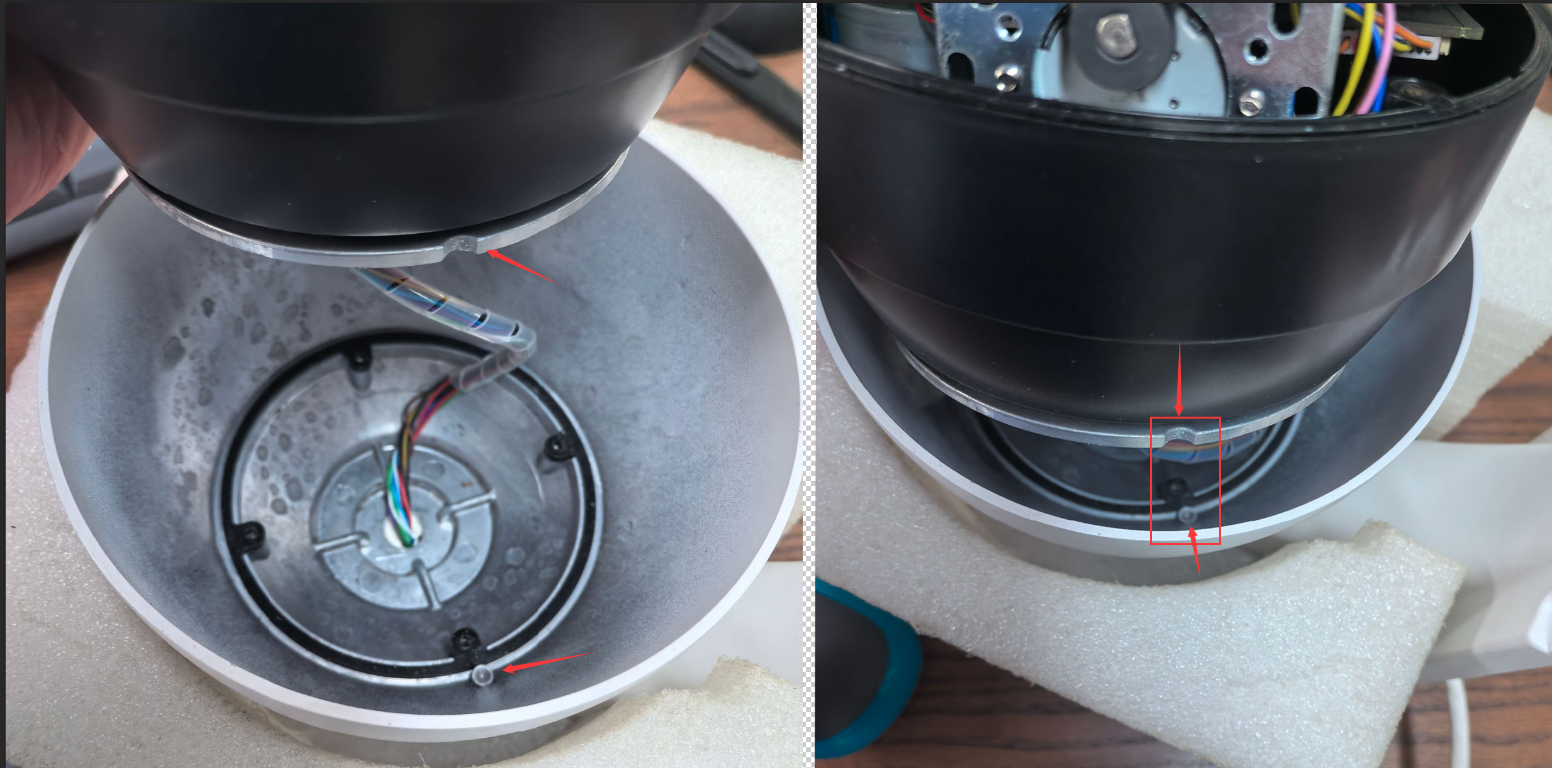

Align the two parts, put down the black plate, and then install the four screws according to the above method. Restore the camera again. The replacement of the POE module has been completed

